Zachary Orton
4/4/2023
PS#8
P1)

Stiffness/Damping Control

Discuss: Stiffness control has decent tracking in free space and it is similar with both wall stiffnesses. It does not seem to limit the force during wall contact very well when initially impacting the wall, especially with a stiff wall. There is a big spike in force when first contacting the wall. With this control no force sensor is required.

P2)

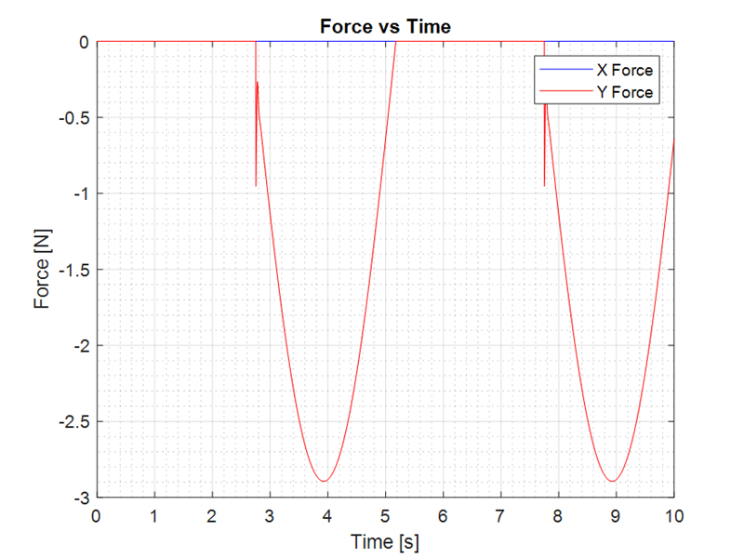

Impedance Control with Stiffness/Damping/Inertia

Discuss: Impedance control has better tracking in free space than stiffness control and the tracking is similar with both wall stiffnesses. There is a big spike in force when first contacting the wall however it corrects down to a lower force much quicker than stiffness control. With this control a force sensor is required.

P3)

Compliance Control

Discuss: Compliance control seems to have better tracking in free space than Impedance control and the tracking is similar with both wall stiffnesses. There is still a big spike in force when first contacting the wall however it corrects down to a lower force even quicker than compliance control and this spike is smaller than with Impedance control. With this control a force sensor is required.

P4)

Admittance Control
Discuss: Admittance control to has the worst tracking in free space when compared to the other controllers. Admittance control goes unstable with higher wall stiffnesses as we can see when the wall stiffness is at 10. With this control a force sensor is required. Even though this has the worst performance compared to the other controller admittance control can let us be more precise with turning how we would like our end effector to act. It is also possible that there are better values that could be found to give us better tracking with the low stiffness wall.

